Collage of Computer Science and Engineering

|  |  |  |  |
| --- | --- | --- | --- |
| **Name:** | Alanoud Al-Thani | **ID:** | 201305622 |
| **Name:** | Hemyan AL-Kuwari | **ID:** | 201401812 |
| **Name:** | Salsabil Hamade | **ID:** | 201403395 |

Spring 2018

**Project Title:** Online Retail Application Database Project

Our application is about register to the Online Retail to purchase an item. The visitor or the customer will sign in by bank account number and bank name. After that the customer will have its own customer id and password. Customer can purchase one or more items with various classes based on their prices. Letter on, purchasing items by the customer, bill will be generated including the quantity, price of the item and discount (if any) on the purchased items. A bank account is required to settle the bill. One or more suppliers can ship the same item. Our application is to develop the database management system that fulfills Online Retail application requirements by adding Customer Order that need customer registration and customer purchase if the customer wants to be a member, he need to register the form that contain name, email, phone number, account number, bank name etc. and customer purchase the item, quantity of item is bought. In addition, we develop the system by inventory updates and it needs item sold, replenished, out of stock, sales. Moreover, Inventory updates wants place an order according to the less stocks and place them to a supplier and purchase products if supplier accepts the order, purchase the products then company add new item to system. Also, to Sales After the products is ordered, sales can be done. Moreover, we develop the system by a windows builder (gui) to be more clarifying and enjoyable. We use also programs are SQL and eclipse that help us to make good and exciting program.

**ER Diagram:**

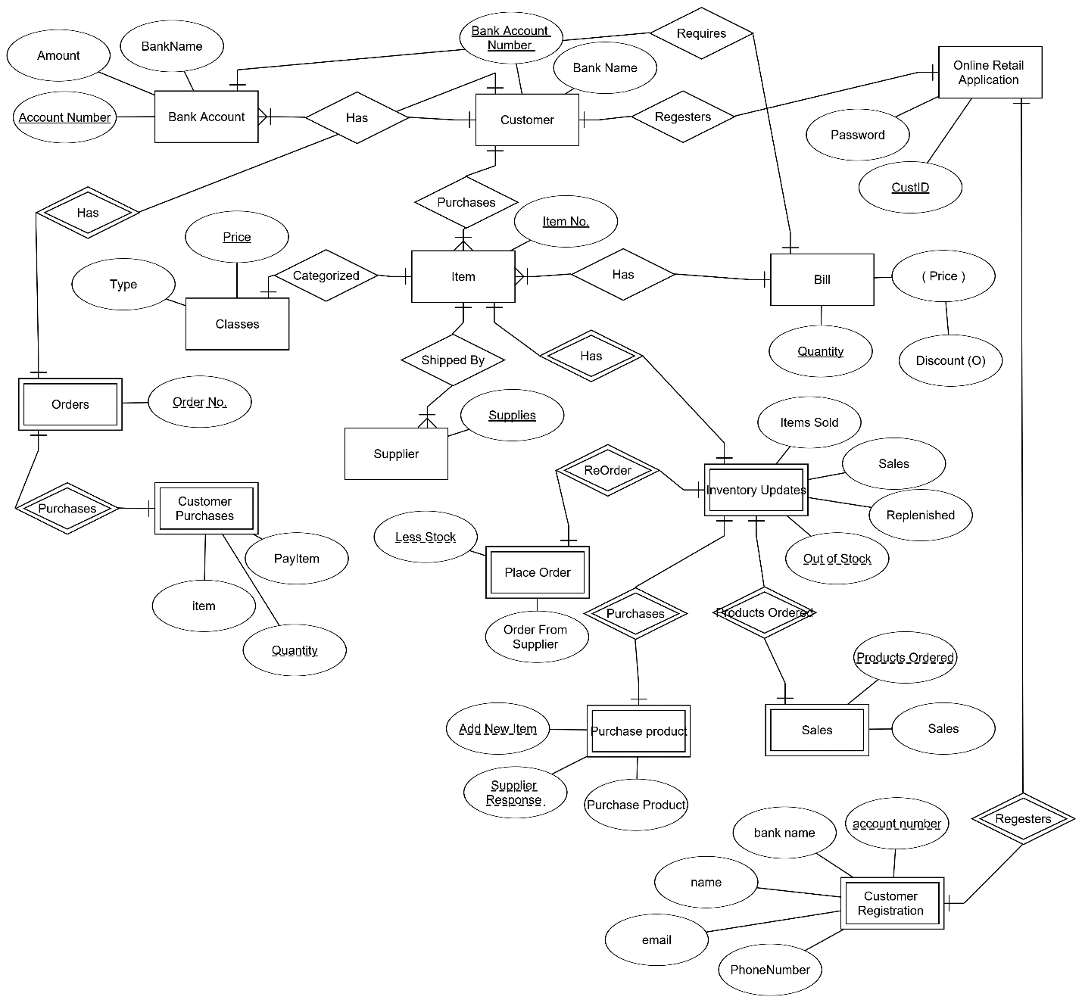

**Normalization:**

**Cust (BAccNo, BName, custID, itemNo, orderNo)**

**OnlineApp(pass,custid, BAccNo, AccNum)**

**Bill(discount,quality, price, accNum)**

**InvenUpdate (itemSold, sales, replenished, outOf Stock, itemNo, lessStock, addNewItem, prodorder)**

**Item (itemNo, bAccNum, price, quality)**

**Classes (type, price, itemNo)**

**BankAccount (accNum, amount, bank, quantity, BAccNo )**

**Orders (orderNo, accNum, quantity )**

**CustPurch (item, payItem , Quantity, orderNo)**

**Supplier (supplies , itemNo )**

**PurhProduct (addNewItem, suppResp, purchPro, outOfStock )**

**CustRegi (accNum, bName, custName, custEmail, custMoblie, custID )**

**Sales (prodOrder, sales, outOfStock )**

**placeOrder(lessStock, orderFromSupp, outOfStock)**

**SQL:**

-- CREATING TABLES

-- Table Customer:

create table cust (BAccNo number(9), Bname varchar2(30), constraint cust_BAccNo_pk primary key(BAccNo));

-- Table Item:

create table item (itemNo number(5), constraint item_itemNo_pk primary key(itemNo));

-- Table Classes:

create table classes(price number(6,2), type varchar2(25), constraint classes_Price_pk primary key(price));

-- Table Bank Account:

create table bankAccount (accNum number(9), Bname varchar2(25),amount number(7,2), constraint bankAccount_accNum_pk primary key(accNum));

-- Table Online Retail Application:

create table onlineApp (custID number(9), pass varchar2(20), constraint onlineApp_CustID_pk primary key(custID));

-- Table Customer Regestration:

create table custRegi (accNum number(9), bName varchar2(30), custName varchar2(25), custEmail varchar2(40), custMobile number(8), constraint custRegi_accNum_pk primary key(accNum));

-- Table Bill:

create table bill (quantity number(3), price number(3,2), discount number(3,2), constraint bill_quantity_pk primary key(quantity));

-- Table Orders:

create table orders (orderNo number(9),constraint orders_orderNo_pk primary key(orderNo));

-- Table Customer Purchases:

create table custPurch(quantity number(3), item number(5), payItem varchar2(30), constraint custPurch_quantity_pk primary key(quantity));

-- Table Supplier:

create table supplier(supplies number(3),constraint suppkier_supplies_pk primary key(supplies));

-- Table Place Order:

create table placeOrder (lessStock varchar2(30), orderFromSupp varchar2(30), constraint placeOrder_lessStock_pk primary key(lessStock));

-- Table Purchase Product:

create table pruchProduct(addNewItem number(9), suppResp varchar(3), purchPro varchar2(30),constraint purchProduct_addNewItem_pk primary key(addNewItem), constraint purchProduct_suppResp_ck check(suppResp='YES' or suppResp='NO'));

-- Table Sales:

create table sales(prodOrder varchar2(30), sale number(3,2), constraint sales_prodOrder_pk primary key(prodOrder));

-- Table Inventory Updates:

create table invenUpdate(outOfStock varchar2(3), sales number(3,2), replenished varchar2(3), itemSold varchar2(3),constraint invenUpdate_outOfStock_pk primary key(outOfStock), constraint invenUpdate_outOfStock_ck check(outOfStock='YES' or outOfStock='No'), constraint invenUpdate_replenished_ck check(replenished='YES' or replenished='No'), constraint invenUpdate_itemSold_ck check(itemSold='YES' or itemSold='No'));

-- Relations:-

-- Relations from or to Customer table:

-- Has:

alter table bankAccount add (BAccNo number(9), constraint bankAccount_BAccNo_fk foreign key(BAccNo) references cust (BAccNo));

-- Purchases:

alter table Item add (BAccNo number(9), constraint Item_BAccNo_fk foreign key(BAccNo) references cust (BAccNo));

-- Regesters:

alter table onlineApp add (BAccNo number(9), constraint onlineApp_BAccNo_fk foreign key(BAccNo) references cust (BAccNo));

alter table cust add (custID number(9), constraint cust_custID_fk foreign key(custID) references onlineApp (custID));

-- Has:

alter table orders add (BAccNo number(9), constraint orders_BAccNo_fk foreign key(BAccNo) references cust (BAccNo));

alter table cust add (orderNo number(9), constraint cust_orderNo_fk foreign key(orderNo) references orders (orderNo));

-- Relations from or to Item:

-- Has:

alter table Item add (quantity number(3), constraint Item_quantity_fk foreign key(quantity) references Bill (quantity));

-- Shipped By:

alter table supplier add (itemNo number(9), constraint supplier_itemNo_fk foreign key(itemNo) references Item (itemNo));

-- Categorized:

alter table classes add (itemNo number(9), constraint classes_itemNo_fk foreign key(itemNo) references Item (itemNo));

alter table item add (price number(6,2), constraint item_price_fk foreign key(price) references classes (price));

-- Has:

alter table invenUpdate add (itemNo number(9), constraint invenUpdate_itemNo_fk foreign key(itemNo) references Item (itemNo));

alter table item add (outOfStock varchar2(3), constraint item_outOfStock_fk foreign key(outOfStock) references invenUpdate (outOfStock));

-- Relations from or to Inventory Updates:

-- ReOrder:

alter table invenUpdate add (lessStock varchar2(30), constraint invenUpdate_lessStock_fk foreign key(lessStock) references placeOrder (lessStock));

alter table placeOrder add (outOfStock varchar2(3), constraint placeOrder_outOfStock_fk foreign key(outOfStock) references invenUpdate (outOfStock));

-- Purchases:

alter table invenUpdate add (addNewItem number(9), constraint invenUpdate_addNewItem_fk foreign key(addNewItem) references pruchProduct (addNewItem));

alter table pruchProduct add (outOfStock varchar2(3), constraint pruchProduct_outOfStock_fk foreign key(outOfStock) references invenUpdate (outOfStock));

-- Product Ordered:

alter table invenUpdate add (prodOrder varchar2(30), constraint invenUpdate_prodOrder_fk foreign key(prodOrder) references sales (prodOrder));

alter table sales add (outOfStock varchar2(3), constraint sales_outOfStock_fk foreign key(outOfStock) references invenUpdate (outOfStock));

-- Relation from or to Online Retail Application:

-- Regesters:

alter table onlineApp add (accNum number(9), constraint onlineApp_accNum_fk foreign key(accNum) references custRegi (accNum));

alter table custRegi add (custID number(9), constraint custRegi_custID_fk foreign key(custID) references onlineApp (custID));

-- Relation from or to Bill:

-- Requires:

alter table bill add (accNum number(9), constraint bill_accNum_fk foreign key(accNum) references bankAccount (accNum));

alter table bankAccount add (quantity number(3), constraint bankAccount_quantity_fk foreign key(quantity) references bill (quantity));

-- Relation from or to Orders:

-- Purchases:

alter table orders add (quantity number(3), constraint orders_quantity_fk foreign key(quantity) references custPurch (quantity));

alter table custPurch add (orderNo number(9), constraint custPurch_orderNo_fk foreign key(orderNo) references orders (orderNo));

select * from bankAccount;

insert into bankAccount(accnum, Bname, amount) values (111,'ANGIE',3000);

select bname, amount, accnum from bankAccount where accNum = 111;

insert into bankAccount(accnum, Bname, amount) values (222,'Mary',4000);

insert into bankAccount(accnum, Bname, amount) values (333,'Harry',5000);

insert into bankAccount(accnum, Bname, amount) values (444,'Smar',6000);

insert into cust (BAccNo, Bname) values ( 345, 'saski');

insert into cust (BAccNo, Bname) values ( 435, 'Hassan');

insert into cust (BAccNo, Bname) values ( 534, 'Omar');

insert into cust (BAccNo, Bname) values ( 045, 'Malak');

insert into item (itemNo) values (456);

insert into item(itemNo) values (900);

insert into item(itemNo) values (100);

insert into item(itemNo) values (780);

insert into classes ( price, type) values (45.00,'plastic');

insert into classes ( price, type) values (467.00,'glass');

insert into classes ( price, type) values (678.23,'metal');

insert into classes ( price, type) values (890.78,'gold');

insert into bankAccount (accNum, Bname, amount) values (657,'sara', 8900);

insert into bankAccount (accNum, Bname, amount) values (597,'alaa', 8009);

insert into bankAccount (accNum, Bname, amount) values (757,'ola', 8090);

insert into bankAccount (accNum, Bname, amount) values (758,'farid', 1000);

insert into onlineApp(custID,pass) values (1,'qwe19970');

insert into onlineApp(custID,pass) values (2,'df_2345');

insert into onlineApp(custID,pass) values (3,'lkjh-8k8h');

insert into onlineApp(custID,pass) values (4,'plmn&567');

insert into custRegi (accNum, bName, custName, custEmail,custMobile) values (1256,'joe','mick','mick@hotmail.com',5678904);

insert into custRegi (accNum, bName, custName, custEmail,custMobile) values (2156,'jamil','nicky','nicky@hotmail.com',65434343);

insert into custRegi (accNum, bName, custName, custEmail,custMobile) values (5621,'jan','max','max@hotmail.com',9999999);

insert into custRegi (accNum, bName, custName, custEmail,custMobile) values (1256,'jamika','salim','salim@hotmail.com',565656);

insert into orders (orderNo) values (290);

insert into custPurch (quantity, item ,payItem) values (4,2,'Yes');

insert into custPurch (quantity, item, payItem) values (5,1,'No');

insert into custPurch (quantity, item, payItem) values (2,5,'Yes');

insert into supplier (supplies) values (190);

insert into supplier (supplies) values (200);

insert into supplier (supplies) values (340);

insert into supplier (supplies) values (234);

insert into placeOrder ( lessStock,orderFromSupp) values ('yes','yes');

insert into placeOrder ( lessStock,orderFromSupp) values ('No','No');

insert into pruchProduct (addNewItem,suppResp,purchPro) values (78912,'NO','table');

insert into pruchProduct (addNewItem,suppResp,purchPro) values (97182,'YES','door');

insert into pruchProduct (addNewItem,suppResp,purchPro) values (10000,'NO','seats');

insert into sales(prodOrder,sale) values ('wood',4.7);

insert into sales(prodOrder,sale) values ('iron',7.2);

insert into sales(prodOrder,sale) values ('matel',2.2);

insert into invenUpdate (outOfStock, sales, replenished, itemSold) values ('YES',6.2,'YES','YES');

insert into invenUpdate (outOfStock, sales, replenished, itemSold) values ('No',1.2,'No','No');

select * from invenUpdate;

select * from bill;

insert into bill(quantity,price,discount,accnum) values ( 3,4,0.5,111);

insert into bill(quantity,price,discount,accnum) values ( 6,3,0.25,222);

insert into bill(quantity,price,discount) values ( 9,4,3);

insert into bill(quantity,price,discount) values ( 10,4,4);

commit;

**Outputs:**

